EwE linked stanza recruitment
- a brief users’ guide



Version 1, 25 January 2022
Compatible with Ecopath with Ecosim version 6.7 α1
Jeroen Steenbeek
Ecopath International Initiative, Spain

Contents
Scope and purpose 2
Acknowledgements 2
Summary 3
Computations 3
Configuring linked stanza recruitment 4
References 5

Scope and purpose
This document provides usage instructions of linked stanza recruitment in the Ecopath with Ecosim food web modelling approach (Christensen and Walters, 2004; Heymans et al., 2016). If you have any questions, find bugs, or see ways to expand on this functionality please contact us at ewedevteam@gmail.com.
This document was last updated January 2022 to EwE version 6.7.0.0 Alpha prerelease.

Acknowledgements
Linked stanza recruitment was implemented by Jeroen Steenbeek after an idea by Villy Christensen under project EISA: Ecology and management of the invasive snow crab.


Summary
Occasionally, ecosystem modellers run into issues where gender-split populations need explicit modelling. This can occur when empirical data is only available for male or female specimens, or when males and females of key species have markedly different behaviours. We have made a small modification to the Ecopath with Ecosim (EwE) multi-stanza model (Christensen and Walters, 2004), that allows linking recruitment to ensure proportional spawning between two multi-stanza groups, and thus connecting two gender-spilt populations at their foundation.

Computations
At the first Ecosim and Ecospace time steps, a base scalar is calculated:
$$a_{i}=\frac{{NAge1}_{i}}{{NAge1}_{j}}$$ | Eq. 1
where $a$ is the scalar, i is a multi-stanza group whose recruitment is driven by multi-stanza group j, and NAge1 is the number of individuals at age 1, e.g., the number of recruits, for multi-stanza groups i and j. This base scalar serves to maintain the ratio between the number of gender-spit recruits during the simulations.
For every consecutive time step, the number of multi-stanza group i recruits is then set as follows:
$${NAge1}_{i}=a_{i}×{NAge1}_{j}$$ | Eq. 2
Changes to the EwE computations were minimal; the most challenging code changes were made in the Ecospace IBM model (Walters et al., 2010), where parallel computations was reorganized to ensure that multi-stanza recruitment is calculated in the correct order. Ecospace does not yet calculate recruitment success from spatial overlap of the gender-split stanza; this could be a future refinement if needed.
An example of linked recruitment is shown in Figure 1. Here, Ecosim is executed twice for a model that contains separate multi-stanza groups for male and female snow crab. Both multi-stanza groups consist of two life stages each: juveniles and adults. Only the male snow crabs are fished. The model contains no change in environment and fishing other than intensifying effort of the snow crab fishery. In the left panel the multi-stanza recruitment is not linked, in the right panel female recruitment is obtained from the male multi-stanza group.
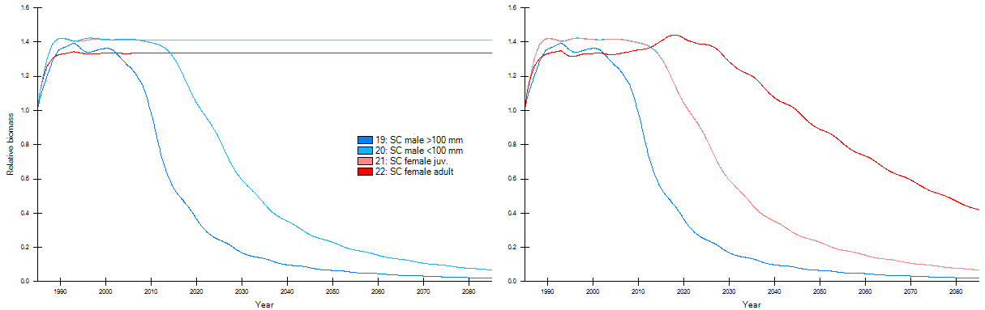
Figure 1 - Two Ecosim simulations for hypothetical fishing pressure on male snow crab, without (left) and with (right) recruitment of females obtained from the male multi-stanza group.

Configuring linked stanza recruitment
First, define the male and female multi-stanza configurations in the “Define groups” interface (Figure 2). In the EISA project, we explicitly modelled male and female snow crab as only male individuals with a carapace size over 100mm were fished.
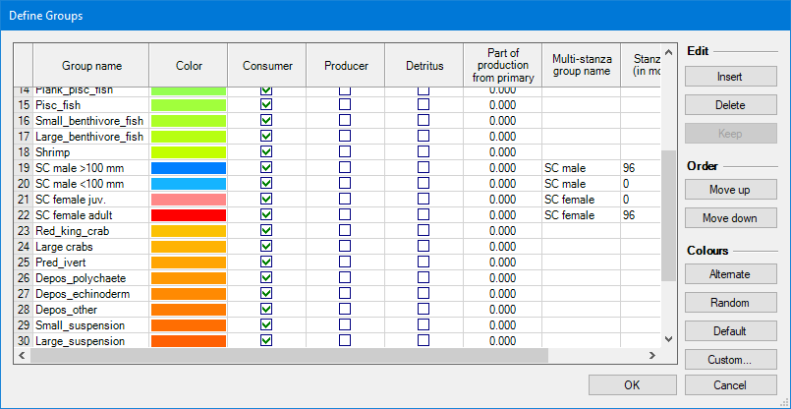
Figure 2 - Define gender-split multi-stanza groups
Second, configure the two gender-split multi-stanza groups in the “Edit multi-stanza” interface (not shown here).
Third, link recruitment in the “Edit multi-stanza” interface (Figure 3). In the EISA project we linked recruitment of female snow crab to the male population as only the males were fished with indirect impacts on female crabs. A multi-stanza group whose recruitment is linked will have its recruitment calculations overwritten, and its defunct “Recruitment Power” parameter therefore becomes inactive in the “Edit multi-stanza” user interface (Figure 3).
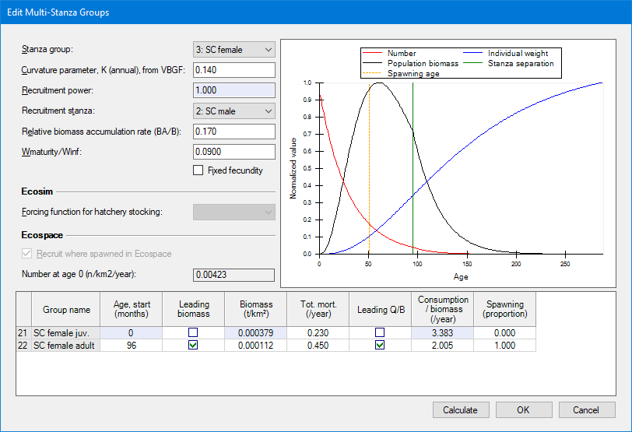
Figure 3 - Linking the recruitment of a multi-stanza configuration to another
.

References
Christensen, V., Walters, C.J., 2004. Ecopath with Ecosim: methods, capabilities and limitations. Ecol. Model. 172, 109–139. https://doi.org/10.1016/j.ecolmodel.2003.09.003
Heymans, J.J., Coll, M., Link, J.S., Mackinson, S., Steenbeek, J., Christensen, V., 2016. Best practice in Ecopath with Ecosim food-web models for ecosystem-based management. Ecol. Model. 331, 173–184. https://doi.org/10.1016/j.ecolmodel.2015.12.007
Walters, C.J., Christensen, V., Walters, W., Rose, K.A., 2010. Representation of multistanza life histories in Ecospace models for spatial organization of ecosystem trophic interaction patterns. Bull. Mar. Sci. 86, 439–459.

